The Roco Digital System
And how to Hack It!
by Francois Kritzinger

Current revision - v0.91

- Hacking the Roco Digital system

  - Introduction
Well, finally! The fun stuff!

But wait! Firstly I have to make sure that every reader that chooses to go beyond this point understands they do so at their own peril! I am not an electronic Engineer, or in any way an electronic expert, and claim no miracles as to what can or can’t be achieved with the Roco Digital system. The reader needs to fully accept that if the equipment is used in the fashion explained below, all warranties that might still apply to his or her equipment, will most likely NOT be honored by Roco or their representatives, as it would constitute using the equipment in manners it was not designed to be used. You continue reading, and choose to use your equipment at your own risk. The author accepts no liability for damage done to any equipment you choose to modify or use as explained!

If you are uncomfortable using a soldering iron, and do some basic electronic work, this might also not be appropriate for you, as some very basic electronic skills are required, this varies from soldering to reading circuit diagrams in some cases. You do so at your own risk!

I have documented only what I have done with my Roco equipment, and will note where appropriate, any failures or error that I made, in order to guide the adventurous to get a little more out of their Roco Equipment.

If you are happy to accept all liability for your own action, feel free to read on.

  - Background
I have been using the Roco Digital system since about 2001, when I purchased my first Roco LokMaus2 system. I eventually acquired a MultiMaus system, then the Rocomotion set (10785) and I also purchased some 2nd hand equipment off the internet to expand my system’s capabilities and keep cost down.

One of the first things I disliked about using the Roco system was that their cables are horribly expensive for a very basic 4 or 6 strand cable. I started looking at solutions and came up with some cost effective solutions. In this search, I realized that the Roco system has been used and modified and hacked by quite a number of people, mostly of German speaking origins, and finding English information proved to be a challenge! Translation software, although helpful, often left lots to be desired, and I was not willing to wager the wellbeing of my DCC system, on badly translated texts! I eventually learnt to read a little German, and become more and clearer about just how much information is available on the web, for those that CAN understand it!

Hence, I decided to compile the fruits of my searches for all to read. Some of the ideas I present here, are my original ideas, others I have taken and used and lastly some I have taken, modified (I will not say improved, as that decision I will leave to the reader) to better suit my needs.

Finally, I would like to reiterate, this is not information I am necessarily qualified to present, or that is approved by Roco and their representatives, I will simply show you what you can do.

The author will attempt to indicate the difficulty of any hack with a rating of 1 to 5, with 1 being really easy, to a 5 being a more complex hack, requiring some electronic skills.

  - Roco Extension cables and splitters for throttles
Difficulty: 1
As mentioned, the typical prices asked for Roco branded extension cables and splitters, are horribly expensive. These cables are VERY easy to make at your home, for much less.

Let’s look at the splitters used for adding LokMaus to your system. They are supplied by Roco as a SLAVE cable with a 2 way splitter attached to one end. The splitter is a standard Telephone splitter. You can use any of the 2, 3 or 4 way splitters available at your local shop. You need a splitter that has a 6p6c setup, i.e., it has 6 positions and 6 connections inside the socket, a 6p4c will also work fine. Look at the following images to see some of the types that can be used.

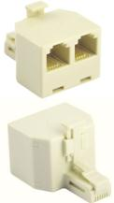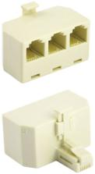
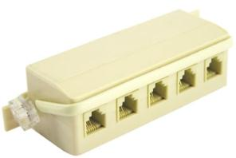

The Roco cables are connected ‘straight through’ unlike regular telephone cable that is ‘cross connected’. To explain, in the Roco system, the cable for throttle/keyboard extension has 4 wires. The wires are connected as follows:
Roco TelCo
Plug A Plug B Plug A Plug B
Pin 1 nc Pin 1 Pin 1 nc Pin 6
Pin 2 Pin 2 Pin 2 Pin 5
Pin 3 Pin 3 Pin 3 Pin 4
Pin 4 Pin 4 Pin 4 Pin 3
Pin 5 Pin 5 Pin 5 Pin 2
Pin 6 nc Pin 6 Pin 6 nc Pin 1

So, we can not use off the shelf cables. Well, you can… cut the cable in the centre somewhere, turn it 180°, and connect the wires so that the effect is as shown on the left table… cheap cable.

Of course the alternative is to just make your own cables from scratch, with custom lengths to suit your layout correctly. Note that the cable on the right comes with a 2 way splitter; just remember to do the cable flip! Or, again, by buying mass produced telco cable you can save a little money, and it already has one plug that is correct. These are some samples of commercially available telco extension cables.

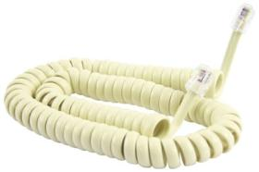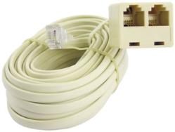

In order to custom manufacture, or modify cables, you will need some of the 6p6c connecters, also known as JR12 connectors. For an example, have a look at the following image…
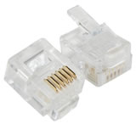

What is required is to add a new plug on the other end of the cable, but turn it 180°, and making sure the wires are connected as in the following diagram.
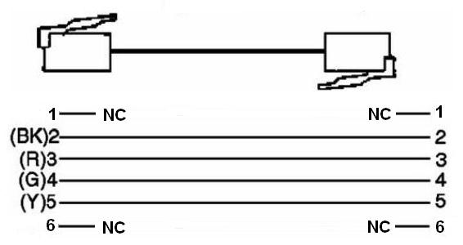

The colors mentioned, are for indication only, and your cable might differ. It is important to focus on the connections rather. To determine what connection is where, hold the RJ12 plug upright in front of you, with the retaining clip towards you, and pointing down. Pin 1 is the right most connector, and pin 6 is the left most connector.

NOTE: This cable CAN NOT be used to connect a throttle to the MASTER port on the Roco booster. The MASTER requires connections on pin 1 1 and pin 6 6 to exist. Should you choose to make universal cables (and not extension cables only) it will be wise to use a 6 strand cable, and connect all 6 strands in the RJ12 plug. But this is not required for additional throttles.

  - Roco Extension cables and splitters for boosters
Difficulty: 3
Don’t worry, the rating of 3 only applies to linking up boosters, WITHOUT modifying your boosters!

As with the Throttle extension cables, the Roco booster cables use a straight through connection, or pin to pin, as explained above. The difference is that the boosters are connected using a 4p4c cable. That is, 4 position 4 connections. This type of plug is also called a RJ9. As can be seen in the following image, this type of plug looks similar to the RJ12 required for throttles, but it is a little narrower, and has less contacts.

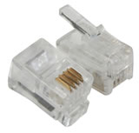
Look at the following diagram for the connections. Again, note that the plugs on the 2 ends are rotated 180° from each other. Also note that all 4 wires are connected…
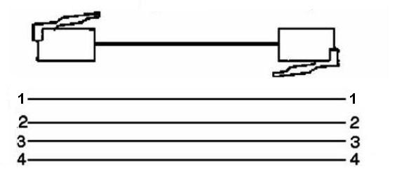

The Roco boosters (10762/10765) can be connected, as mentioned before, up to 4 to a single amplifier (10761/10764). All that is required is a booster cable plugged into the BOOSTER OUT socket on the amplifier, and the other end in the BOOSTER IN on a booster.

That is all good, but what if we have 3 start set amplifiers, like the 10761 or 10764 models? Can’t we use them as boosters? The answer is YES YOU CAN! Please also read the next section along with this one!

When we open the amplifier and the boosters, it can be seen that the units are very similar internally, in fact, the amplifier has connections for BOOSTER OUT, SLAVE and MASTER, and a booster has connections for BOOSTER IN and BOOSTER OUT, but no master/slave ports. On further inspection, it is noted on a booster, that the BOOSTER IN and BOOSTER OUT ports are connected directly, pin to pin! I.e., pin 1 on BOOSTER IN is connected to pin1 on BOOSTER OUT! This is great news, since we can now make these connections EXTERNALLY, and use amplifiers as add on boosters!

What is needed is 5 RJ9 sockets and some wire and some soldering skills… we simply connect the same pins on the RJ9 sockets together, and connect an amplifier via its BOOSTER OUT connector to one socket on our splitter! Just remember that we can only connect throttles to the MASTER AMPLIFIER, the other amplifiers (now used as boosters) should never have any throttles connected. It might be a good idea to place some black tape over the MASTER and SLAVE ports on these additional amplifiers.

Also, remember to insulate BOTH rails of the track between amplifiers, or their magic white smoke might escape, or you might be hassled with short circuit shutdowns all the time!

Below is a diagram to explain how to wire the RJ9 sockets together.

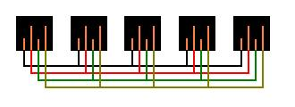

Also remember, each booster MUST have its own power supply, and its own pair of track connections.

  - Modifying Roco Amplifiers to operate as Boosters in a Roco DCC system
Difficulty: 3
Now you might ask, why would I want to do this? The answer is simple, because you can, and, why spend money if you already have the gear?

Roco would like us to believe we have to purchase a 10762 or 10765 BOOSTER in order to expand our DCC setup, when we might already have 2 or 3 DCC Starter sets, each having its own amplifier.

Why does this work? If you recall from the information about the Roco DCC system, you ill remember that the Command Centre is actually the MultiMaus connected to the MASTER socket on an Amplifier. The only thing that distinguishes an Amplifier from a Booster in the Roco perspective is the external connections. Amplifier has a BOOSTER OUT, and MASTER and SLAVE throttle connections, where as a Booster, has BOOSTER IN and BOOSTER OUT connections only.

If we look even further into the internal connections of a Roco Amplifier, we discover that the pins 1 and 6 (which you might recall is NOT REQUIRED for additional throttles) are connected internally between MASTER and BOOSTER OUT! We also see that the SLAVE connector has got no connections on pins 1 and 6, and that pins 2 – 5 are connected straight through between the MASTER and SLAVE ports on the Amplifier!

See the table below for the connections.

The pins are connected as follows:

10761/10764 Amplifier
BOOSTER OUT SLAVE MASTER
Pin 1 --------------------------------------------------> Pin 1
Pin 2 ---------------> Pin 2
Pin 2 | Pin 3 ---------------> Pin 3
Pin 3 | Pin 4 ---------------> Pin 4
Pin 5 ---------------> Pin 5
Pin 4 --------------------------------------------------> Pin 6

From this we can then assume that the DCC signal is ‘written’ on pin 1 and 6 by the master throttle, and is in turn ‘read’ by the amplifier and additional boosters, on pins 1 and 4 of the booster socket.

This knowledge expands our horizons even further, which will be discussed in the next section. For now, let’s just focus on using the amplifiers as boosters.

If the route explained above, with external connectors does not appeal to you, you might want to consider adding the BOOSTER IN port on your amplifier/s and, while you have the unit open, remove the MASTER and SLAVE sockets for safety sake…

This is how it is done.

    - When looking at your Roco Amplifier from the either of the narrow sides that does not have the lights or connectors, you will notice 2 small black pins on one end. These pins are simply pushed in tightly, and can be removed with a small knife, by lifting the pins out and placing them somewhere safe for later replacement. There are 4 pins, 2 on each side.
    - Slide the top and bottom halves of your amplifier apart. There is a small catch in the top center of each of the bottom and top halves. To release them, simply push inward on the narrow sides you just removed the pins from. It will pop open, and you can slide the 2 halves apart.
    - One part is only the plastic shell; the other part is the one we’re interested in. It has a small circuit board attached to it by 4 small screws. Remove the 4 screws, and store them away safely!
    - Looking at the board, you will notice a small gap between the BOOSTER OUT, and MASTER/SLAVE ports. Look at the following diagram, where the RED arrow indicates
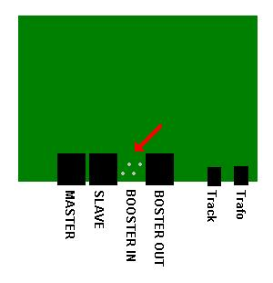
We need to put a socket in there now.
    - using a small drill bit, drill out the holes where the 4 silver solder pads are, taking care to drill straight and in the center of each pad
    - Place the RJ9 socket into the 4 holes, and pushing it all the way down. Turn the board over.
    - Now carefully solder the 4 pins sticking through he back to their respective pads, making sure there are no extra solder anywhere that can cause a short circuit. Trim the extra length off the 4 pins you just soldered
    - For safety, remove the 2 RJ12 ports for MASTER and SLAVE on all the amplifiers you intend to use as boosters. Heat each of the pins with your soldering iron, and using small flat tip screwdriver, try to pry the wire out of the hole, until all 4 wires are loose. Now simply remove the black plastic socket.
    - To finish off, you will need to cut a hole for the new BOOSTER IN port in the casing of your old amplifier. Drill small holes all around the perimeter of the large square hole you need, and cut out the middle piece with a sharp knife. A needle file can be used to smooth up the edges.
    - Now glue some black plastic to the inside of the enclosure where the MASTER/SLAVE ports were removed, or stick some black tape over the holes left.
    - Replace the board, and replace the 4 screws used to keep the board in place
    - Slide the enclosure shut, and replace the 4 retaining pins

Now your new Booster is ready for action! To start using it, you will need a section of track that is connected to, but isolated from the track connected to a different booster. You also need a booster cable that is connected from the amplifier BOOSTER OUT to the Booster’s BOOSTER IN (or OUT as they are internally connected) port.

Start up your Roco digital system, and place a loco on the track. Attempt to travel over the isolated joint in the track. If you get a short (the MultiMaus should detect it and shut down), turn the 2 track wires around on the additional booster, i.e., change the left and right rail connections for the booster only.

Try the same again, it should now work. This process needs to be repeated for each booster in your system, until the track connection wires are all in phase.

That is that!

