The Roco Digital System
And how to Hack It!
By Francois Kritzinger

Current revision - v0.91

- The Roco Digital System

  - Roco System configurations and options
Despite having all these items, the Roco DCC system requires only 3 components to operate:
- A controller (which also doubles as a command station) (viz. LokMaus2 or LokMaus3, PowerMouse, MultiMaus or MultiMaus/PRO)
- A Booster to put the DCC signal and power together and on the track (Either a 10761, 10 764 or 10832)
- A Power supply

This basic system can be extended in a number of ways:
- By adding additional throttles (or handheld controllers) (viz. LokMaus2 or LokMaus3, PowerMouse or MultiMaus)
- By adding better (more capable) throttles as slave or command station (MultiMaus)
- By adding a turnout control keyboard
- By adding additional power boosters (This can be either 10761/2 or 10764/5)
- By adding a computer interface (using RS232/Serial port) (Rocomotion (10785)
- By adding feedback modules
- By adding automatic brake generators
- And most recently, by adding a wireless controller/s and USB computer interface (MultiMaus/PRO)

The basic system’s features are as follows:
- 99 loco addresses (only 2 digit addresses)
- 2.7Amps of current
- 4 function control buttons
- POM or Direct programming modes (changing CVs directly, again limited to CV 1-99 with values of 1-99 only)
- Speed control and direction in 1 knob, with a centre off position
- 14, 28 or 128 speed steps
- Walk around control (as long as master throttle is never unplugged!)

Notably, the following are missing from this system:
- Reading back of CVs from a decoder (VERY useful when programming CVs directly or tweaking loco performance)
- Consist of multiple locomotives
- 4 digit addresses for decoders
- Extended CV programming (often required for Sound equipped locos)
- Functions 5-22 (often required for Sound equipped locos)
- Ability to Control DCC equipped turnouts (or points for readers in other parts of the world)
- Dedicated Programming Track outputs
- Wireless walk around

In order to fill the missing gaps left in the basic Roco Digital system, we can add some optional extra components, in various ways. Although these are extra cost items, they do fix what might be perceived as ‘missing’ from the basic sets.

As a feature is listed from the short comings listed above, they will be highlighted in bold to simplify seeing what additional features are added from the list…

By simply adding a MultiMaus as the Master throttle (and so the Command Station), the picture changes as follows. In addition to the basics, we get:
- 4 digit addresses
- 3.2Amps of current
- Full access to all CVs and all their values
- Better short circuit protection/detection
- 20 function keys (10 direct buttons, and 10 in combination with SHIFT button)
- Locomotive naming library (limited to 5 characters only)
- Turnout (point) control from MultiMaus

When we add the Rocomotion Computer interface, we get the following:
- Use of computer as a throttle/controller
- Ability to add feedback from track sensors to computer
- Reading of CV values from decoders
- Consisting
- Automated train control (either as a shuttle train, or additional traffic)
- Serial computer interface
- Dedicated Programming Track outputs

Finally, by adding the MultiMaus/PRO system to your configuration, or in place of Rocomotion above, we have the last missing bits:
- Wireless walk around Throttles (using 2.4gHz Radio Frequency, not Infra Red as other cheap systems)
- USB computer Interface
- Reading of CV values from decoders
- Consisting
- Automated train control (either as a shuttle train, or additional traffic)
- Dedicated Programming Track outputs

As this clearly indicates, the Roco system is MUCH more comprehensive that many others, although not everything IS shipped in one box. Yes, it is additional cost items, but by adding the bits you need, YOU, the user, can decide what is important to your needs, and only pay for what you need. Other ‘all-in-one’ systems that has everything demand a premium for their product, and many functions it includes, which are NOT required by everyone. So consider the Roco DCC system as a sort of ‘Lego Set’ of DCC functionality, you build what you need!!! And it WILL grow with your layout.

  - Connecting the Roco components together
One might think this is crazy to add these diagrams in here, but there are some problems in getting information on how to connect the Roco components, as simple as the system actually is!

As can be seen in the diagram on the next page, connection is not particularly complex. All the Roco items connect using modular cables that will not fit in the incorrect socket. For connection to the Throttle bus, a 6p6c connection is used, and for connecting to the booster bus, a 4p4c cable is used.

These cables (and alternatives) will be discussed later.

It is important/interesting to note, that with the Rocomotion in the setup, the 10785 Rocomotion units, is connected as a slave throttle in the system. The Rocomotion 10785 can not be used as a master throttle, only slave, with either LokMaus or MultiMaus as master. With the MultiMaus/PRO the MultiZentrale becomes the MASTER device, and connecting of the MultiMaus booster is not required.

Another note on the connectivity is that according to the Roco system documentation, the system only supports a master booster, and 4 additional boosters. This is not completely correct… To expand the power handling capabilities of the Roco system, the boosters can be connected as follows:

10761/4 10762/5 10762/5 10762/5 10762/5 10779 10762/5 10762/5 10762/5 10762/5 10779 10762/5 10762/5 10762/5 10762/5... … …

You will notice that after every 4 10762/5 units, a 10779 Brake Generator is installed. This acts as an ADDITIONAL MASTER BOOSTER, with its OWN 4 add-on boosters! This way the system can be expanded to accommodate up to a maximum of 30 booster/brake generators in total. Assuming a 3.2A power rating (as is available using 10765) you have a maximum capability of 90Amperes! More than enough for ANY model railroad!
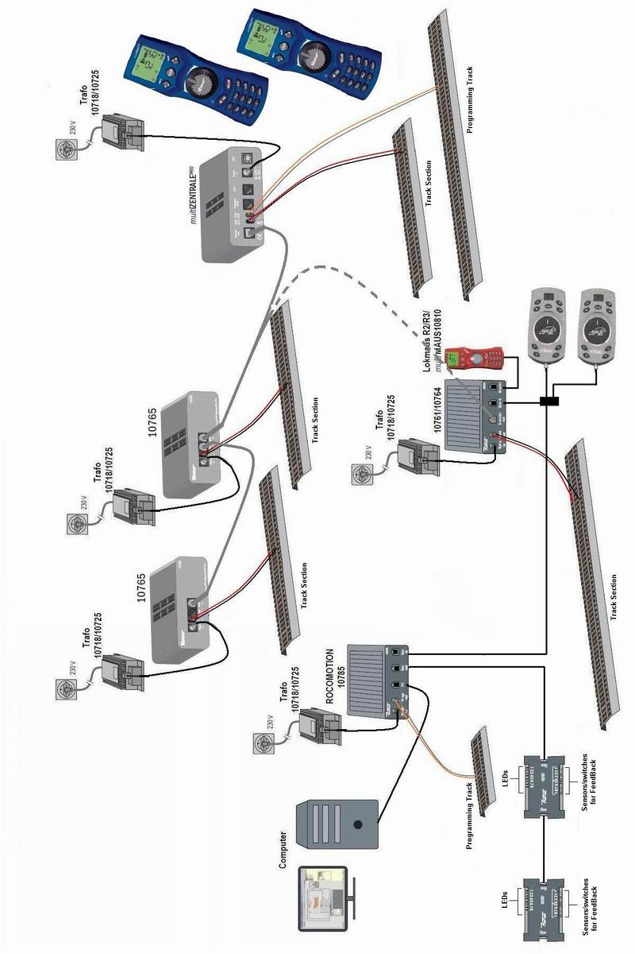
  - Using Roco Digital systems
The Roco digital system, as mentioned earlier, is as user friendly and easy to use as they come! If you understand how to use a conventional throttle with a centre off position, you can use Roco Digital! Only additional bit you need to understand is that each loco needs a decoder installed, and each decoder needs a unique number or address, and you’re away!

Let’s pause for a minute on the subject of programming. Again, most users will never need to understand all the complexities of the CVs available in DCC (although it is a very powerful tool to optimize the performance of an individual loco)

For most users the basics is all that is required, address, and if need be, startup and end voltages, and braking and acceleration effects.

These are individually accessible with the Roco Digital system by pressing (and holding) the ‘P’ button, and pressing one of the function buttons, choosing a value with the up/down buttons, and pressing ‘P’ again, as simple as that.

Should additional programming be required, the computer interface does simplify this a bit, as does MultiMaus.

Another thing Roco did to simplify using different trains, are quick search lists. By pushing (and keeping pushed) either the up or down button, the mouse will scroll past all numbers, and automatically stop at the next number of one of the last 10 locos that was used. Let’s look at an example… Say we only used loco number 3 and 21 on our mouse, and we want to change from loco 3 to 21… Push the UP button, and keep it in. the numbers will scroll by quickly, but will automatically stop at 21. If you want to actually use number 25, push the up arrow again, and stop on 25… quick and simple…

Another one of the issues many of the ‘bigger’ systems have is their intricate and comprehensive startup and shutdown procedures. WHY? We want to run trains, not launch space ships! To power Roco Digital up, plug in and turn on the transformer (assuming all other components are already connected. To finish your session, turn of the plug at the wall and unplug. Each throttle will store its state in its own memory, and startup and continue where you left off.

Why do you have to power up your system, and then tell it to run trains, or have fancy key combinations to shut down!

Why do you need to tell the system that train 25 is no longer in the system, and ‘dispatch’ it?

The user should simply not need to manage the system in such a nitty gritty fashion.

When looking at a DCC system, do not merely look at all the big numbers and large promises made by other manufacturers, as many of those would not be required by many modelers. Also remember, once you have taken out your cash, there’s no turning back! You are stuck with the system you chose. Sure, you can sell it all and restart, but that is such a waste of money!

  - Conclusion
As I have attempted to demonstrate, the Roco Digital system IS very cool, and extremely user friendly. It is simple to use, but, by adding some components, is VERY powerful. As with any other system, I would still urge potential buyers to go out and try the various systems first hand, and see what the system looks like, and how it feels in your hand. Just because something works for me, and I like the interface, it does not mean that it WILL work for you and be a hit for you too…

