The Roco Digital System
And how to Hack It!
by Francois Kritzinger

Current revision - v0.91

- The Roco Digital System

  - Introduction
The Roco Digital system has come quite a ways since the original ‘Digital is Cool’ system was introduced. It has grown from a system with very limited capabilities, into a DCC system worth mentioning in a DCC conversation, without worrying what others would think. Having said that, there is still a huge misconception in the Model Railroad hobby circles, that ‘start set controllers’ are junk, and should not even be considered as a serious DCC proposition! How wrong can they be!!!

  - Background to the Roco Digital System
It is now publicly known that the Roco Digital system was designed by LENZ, the company that created the DCC system, now accepted as the NMRA standard. They are still actively involved in evolving and improving the DCC system, and their most recent contribution to the DCC world is the RailCOM interface, which allows feedback from the locomotive or stationary decoded, to the command station.

Roco, quite wisely, decided not to redesign the wheel, but rather go to somebody that knows electronics, to assist them. Roco on the other hand, knew that not every model railroader was a computer literate, rocket engineer, and that a large portion of the users would be young children, or older model railroaders. In the case of the kids, you can not expect them to understand the intricacies of a complex DCC system, they want to run a train, and be able to control the basics, on the other end of the scale, many older folk, suffer from Technophobia, which is why you often have difficulty getting Dad to MMS you that picture of him and Mom at their holiday home, to your phone. Or why you have to explain to Dad why you don’t need more than one remote control, when a universal can do the job of 6 or 8 other remotes! Let’s not even go into what is facebook and email!

Reality is, some users do not really care about the complexities of a ‘full’ DCC system, they want to run trains and enjoy it! So Roco designers cleverly kept to the ‘KISS’ approach, and added a good dash of the familiarity of a toy train speed controller, and combined it with some really good electronics, to produce the Roco Digital system.
As a result, the second, third and fourth generations of Roco digital, ARE significantly better, although, there are still some shortcomings, which we will discuss next. Most of which DOES have work around. But, as always, it does take some effort, and is thus also more in the realm of the advanced user or enthusiast, and not much missed by the users with simpler requirements.
  - The Roco system components
The Roco range of DCC items is quite complete, and more than capable to fulfil the requirements of most DCC users. Below is a list of the items on offer by Roco at the time of writing this document.

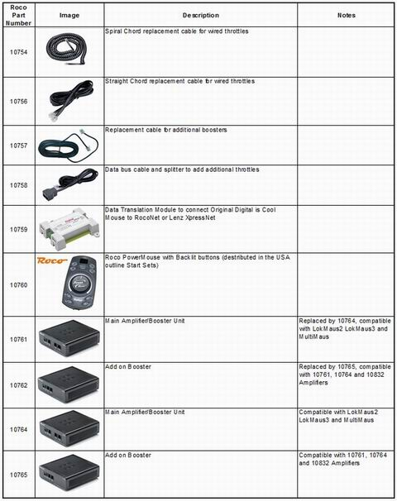
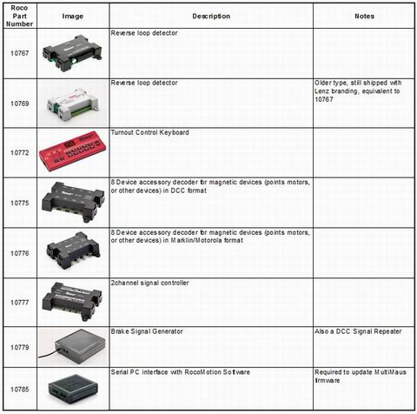

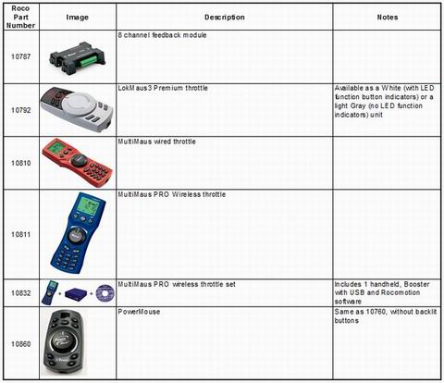

Although some of the listed items might no longer be available NEW, they are included, as they do appear on places like eBay occasionally, and they are still very appropriate to the Roco Digital system, and still very usable!

